**EXPERIMENT-06**

**AIM:**To develop PLC ladder programs using bit logic instructions.

**EXERCISE:**

1) Write a program to using ladder diagram to implement following gates.

a)AND c)NOT e)NOR f)Ex-OR

b)OR d)NAND g)Ex-NOR

I/O LISTING

input1 - I:0.0/0 input2 – I:0.0/1

output – O:0.0/0

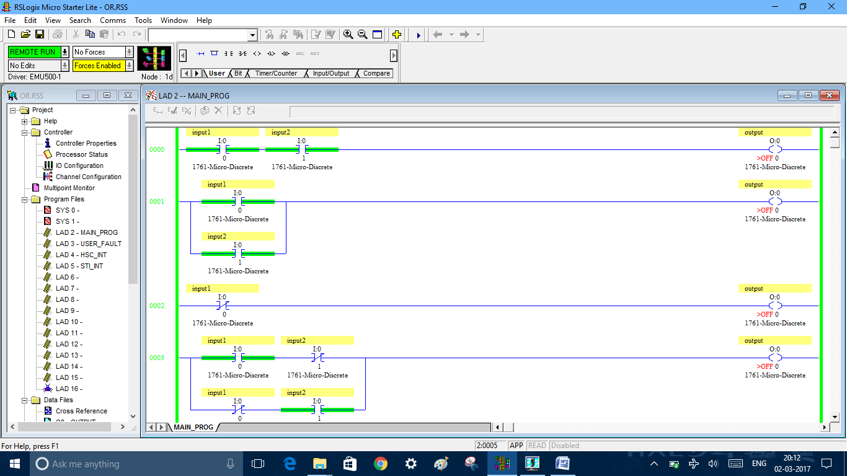

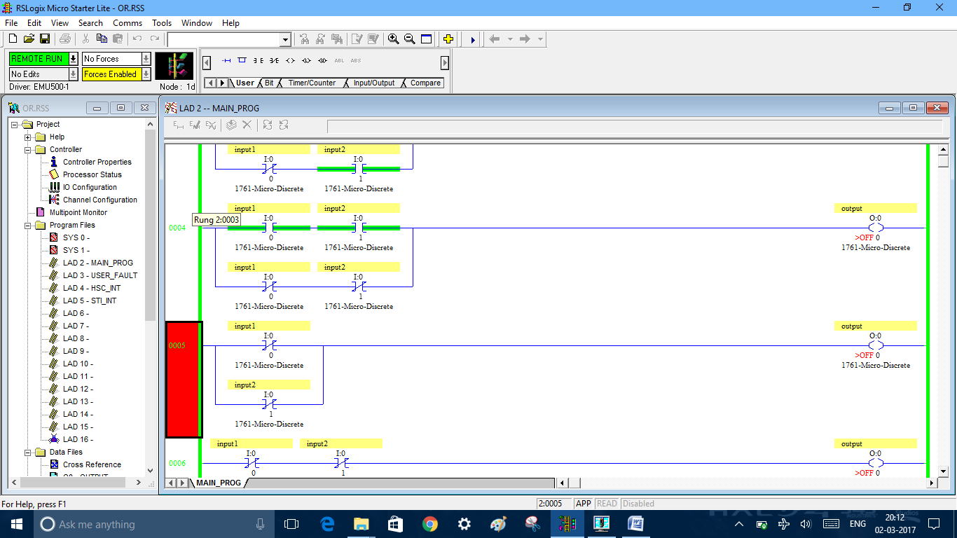

2) Write a program to using ladder diagram to make a motor run in forward and reverse direction.

I/O LISTING

START – I:0.0/0 STOP – I:0.0/1 START BIT – B3:0/0

FORWARD – O:0.0/0 REVERSE – O:0.0/1

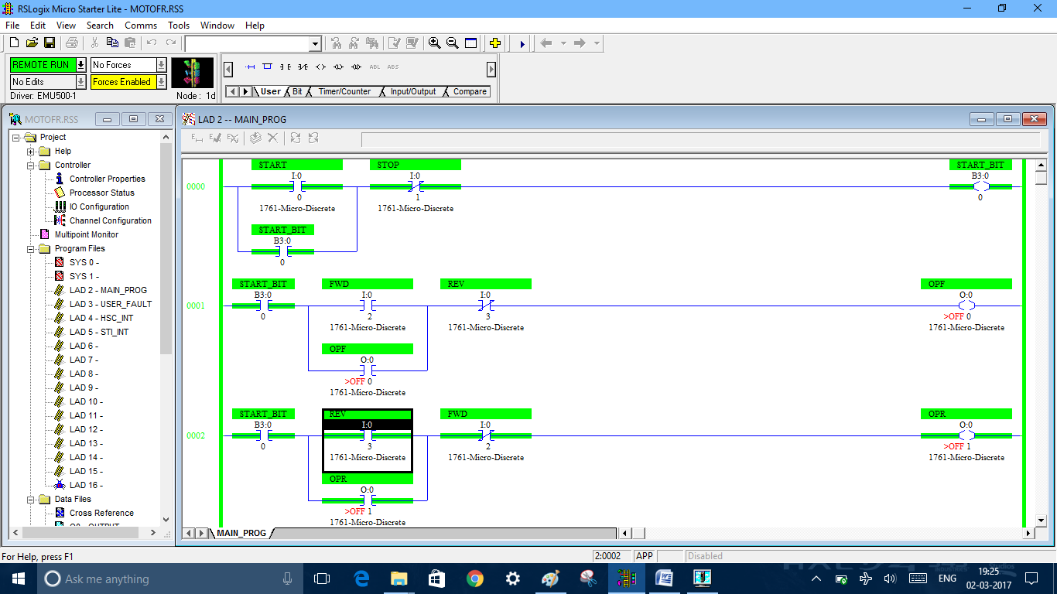

3) Design a 1X4 demultiplexer using ladder logic.Assume suitable I/O.

I/O LISTING

C1 – I:0.0/0 C2 – I:0.0/0 IP – I:0.0/0

OP1 – O:0.0/0 OP2 – O:0.0/1 OP3 – O:0.0/2 OP4 – O:0.0/1

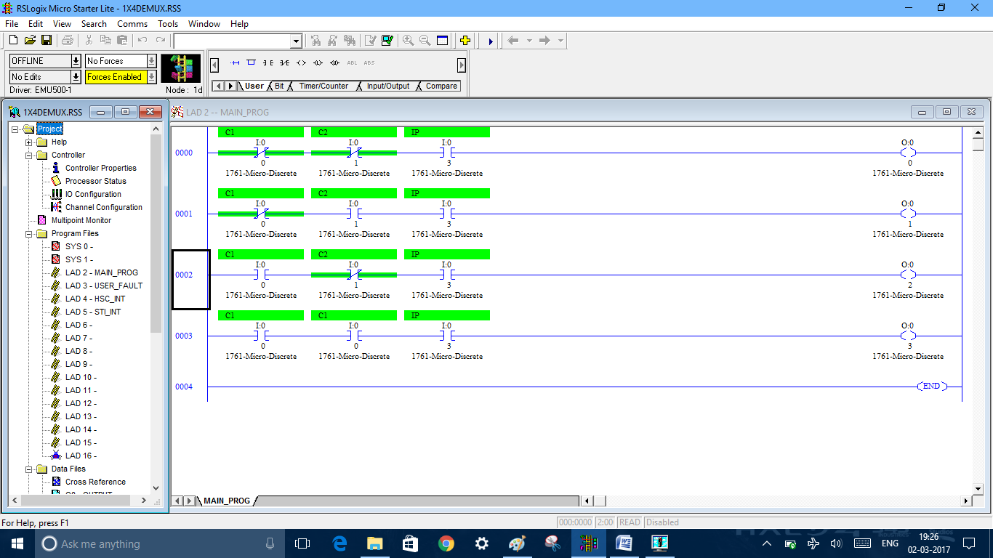

4) Design a 4X1 multiplexer using ladder logic.Assume suitable I/O.

I/O LISTING

IP1 – I:0.0/0 IP2 – I:0.0/1 IP3 – I:0.0/2 IP4 – I:0.0/3

C1 – I:0.0/4 C2 – I:0.0/5 OP – O:0.0/0

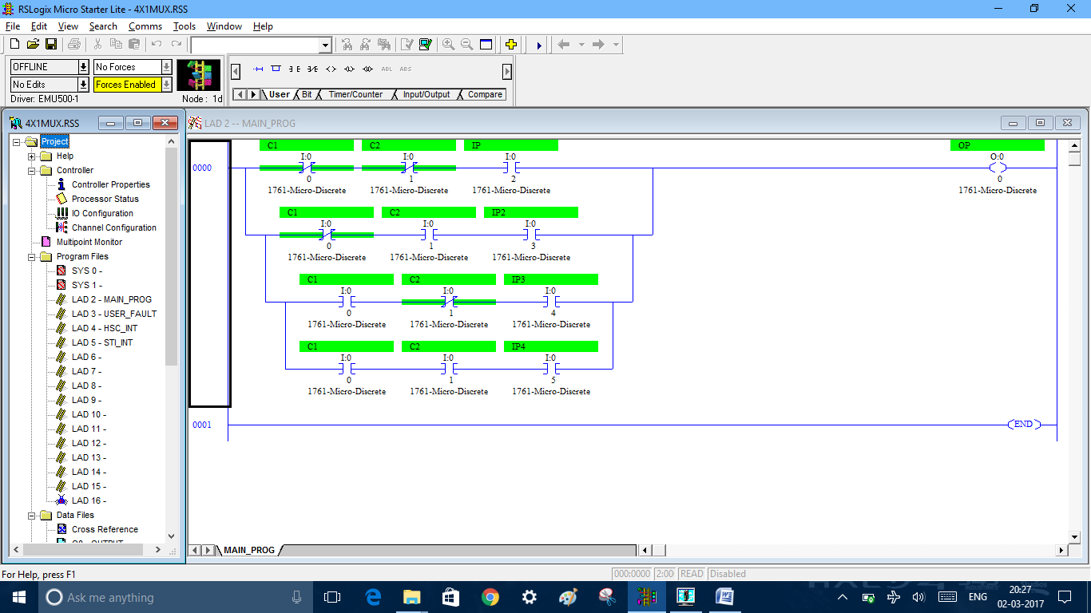

5) Draw a ladder diagram for the problem given below.

There are 3 ejector pumps in a waste management system.only one is to be run at a time.The pump which is to run is chosen at random by an operator.Draw a PLC ladder diagram to fit this problem. Assume suitable I/O.

I/O LISTING

PUMP1 – I:0.0/0 PUMP2 – I:0.0/1 PUMP3 – I:0.0/2 OP – O:0.0/0

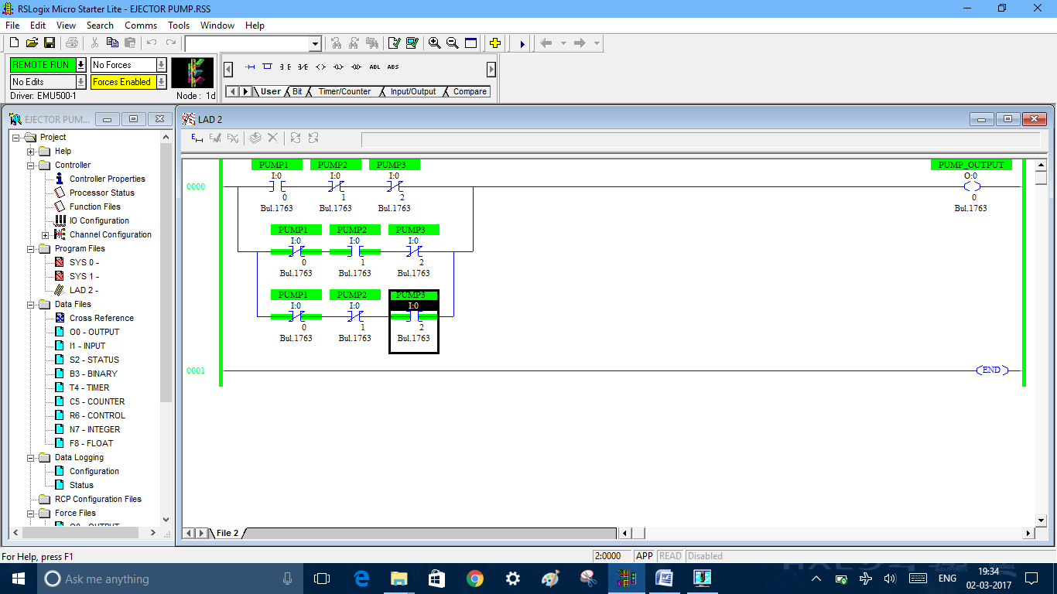

6) A two way hydraulic cylinder has two solenoid controlling it.Energizing one solenoid causes the cylinder to extend and energizing the other solenoid causes it to retract,A limit switch at each end indicates full retraction or full extention,Write a program to using a ladder diagram to control the system

I/O LISTING

START – I:0.0/0 STOP – I:0.0/1 START BIT – B3:0/0

LS1 – I:0.0/2 LS2 – I:0.0/3

SV! – O:0.0/0 SV2 – O:0.0/1

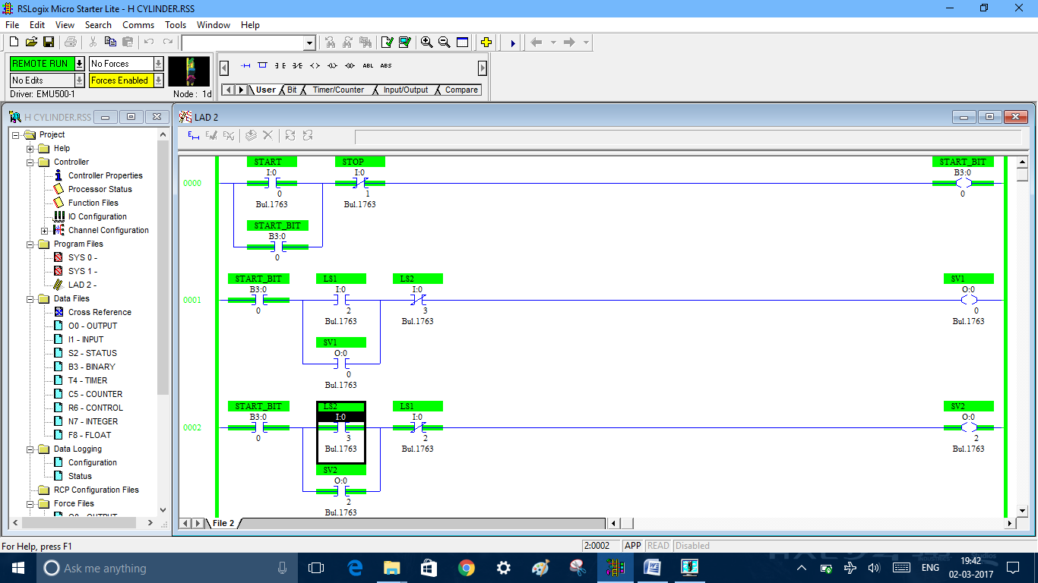

7) Draw the ladder diagram to enable following logic

“For output H to be ON ,input A must be ON and input C and D must be OFF. In addition one of input F, E or G must be ON”

I/O LISTING

A – I:0.0/0 E – I:0.0/2 F – I:0.0/4 H – O:0.0/0

C – I:0.0/1 D – I:0.0/3 G – I:0.0/5

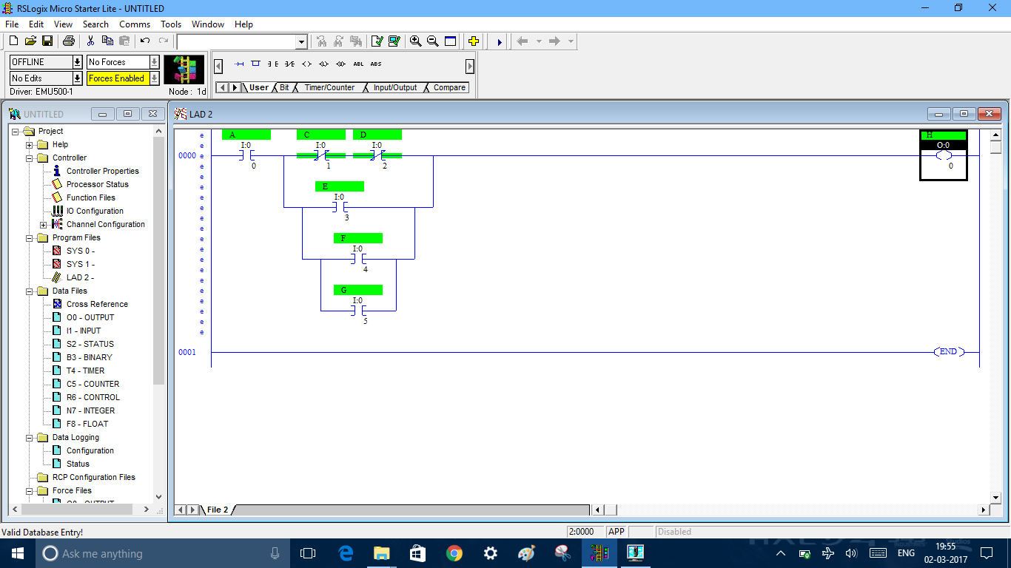

8) Draw the ladder logic for Boolean diagram as given.

I/O LISTING

A – I:0.0/0 B – I:0.0/2 E – I:0.0/4 H – I:0.0/6

C – I:0.0/1 D – I:0.0/3 F – I:0.0/5 G – O:0.0/0

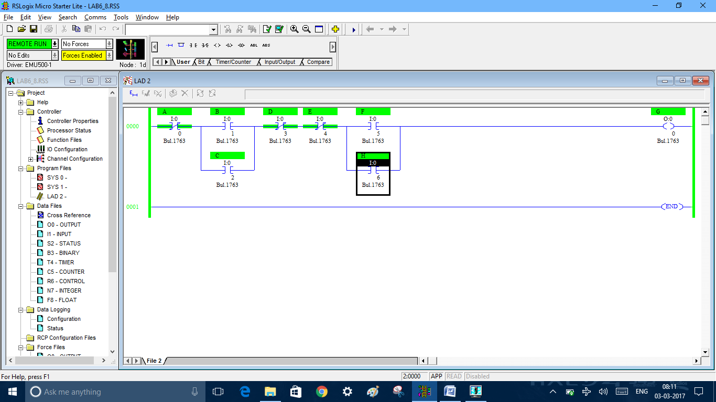

9) A level control system of a water tank has two level switches LS! And LS2 as shown, such water level > 10 cm, LS1 Is ON and when the water level > 80 am then LS2 is ON.Design a ladder diagram to achieve the following objectives:

a) When the water level < 10 cm, turns the pump ON.

b) When the water level > 80 cm, turns the pump OFF.

Separate START and STOP buttons are to be used to power up the system.

I/O LISTING

START – I:0.0/0 STOP – I:0.0/1 START BIT – B3:0/0

PUMP – O:0.0/0 ES – I:0.0/4

LS1 – I:0.0/2 LS2 – I:0.0/3

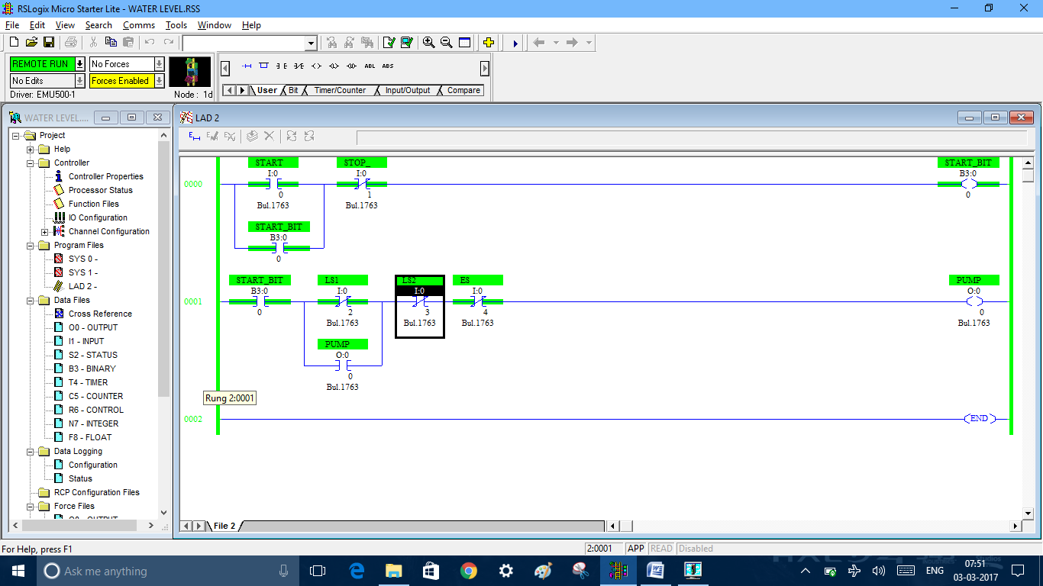

10) A bi directional movable arm is shown.Develop a ladder diagram to control it as per the condition mentioned.Both the statrt and stop switches are push button type. When the system is turn ON the motor should rotate continuously, alternating between the CW and CCW directios ,As the arm touches limit swithes RRL and LLS.

I/O LISTING

START – I:0.0/0 STOP – I:0.0/1 START BIT – B3:0/0

LLS – I:0.0/2 RLS – I:0.0/3

CW – O:0.0/0 CCW – O:0.0/1

